Chapter 7 Elements
extra worksheet 1: Properties of water

Answers
1 Possible answers include
 | Solid | Liquid | Gas
water | ✓ | ✓ | ✓
butter | ✓ | ✓ | ✓
candle wax | ✓ | ✓ | ✓
animal fat | ✓ | ✓
lighter fluid (butane) |  | ✓ | ✓
carbon dioxide | ✓ |  | ✓
2 and 3
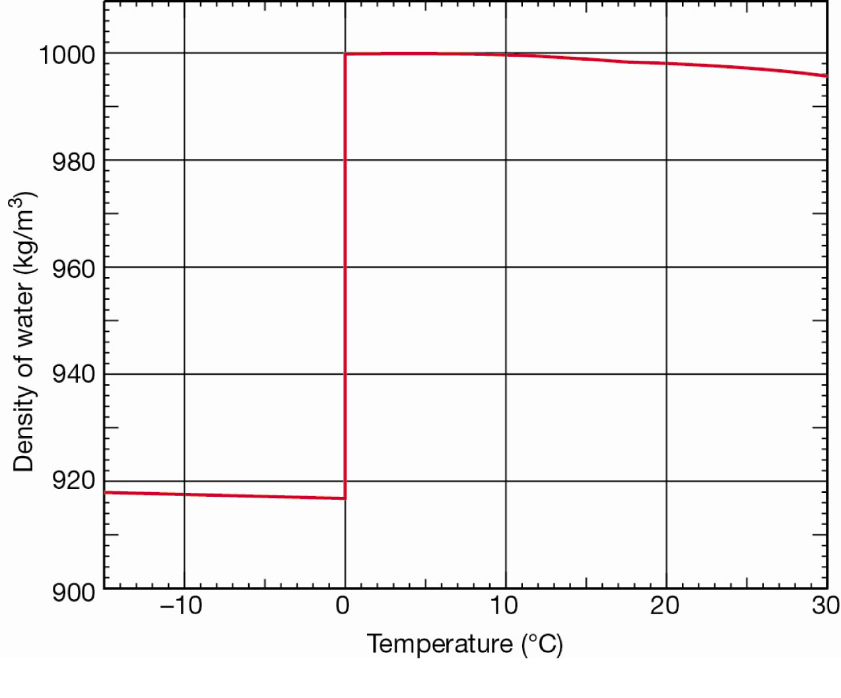
4 At -20°C the density of ice is around 919 kg/m³ and decreases as the temperature is increased to 0°C. Once the ice melts, the density jumps rapidly. It increases slightly until 4°C and then starts to come down again slowly as the temperature is increased further.
5
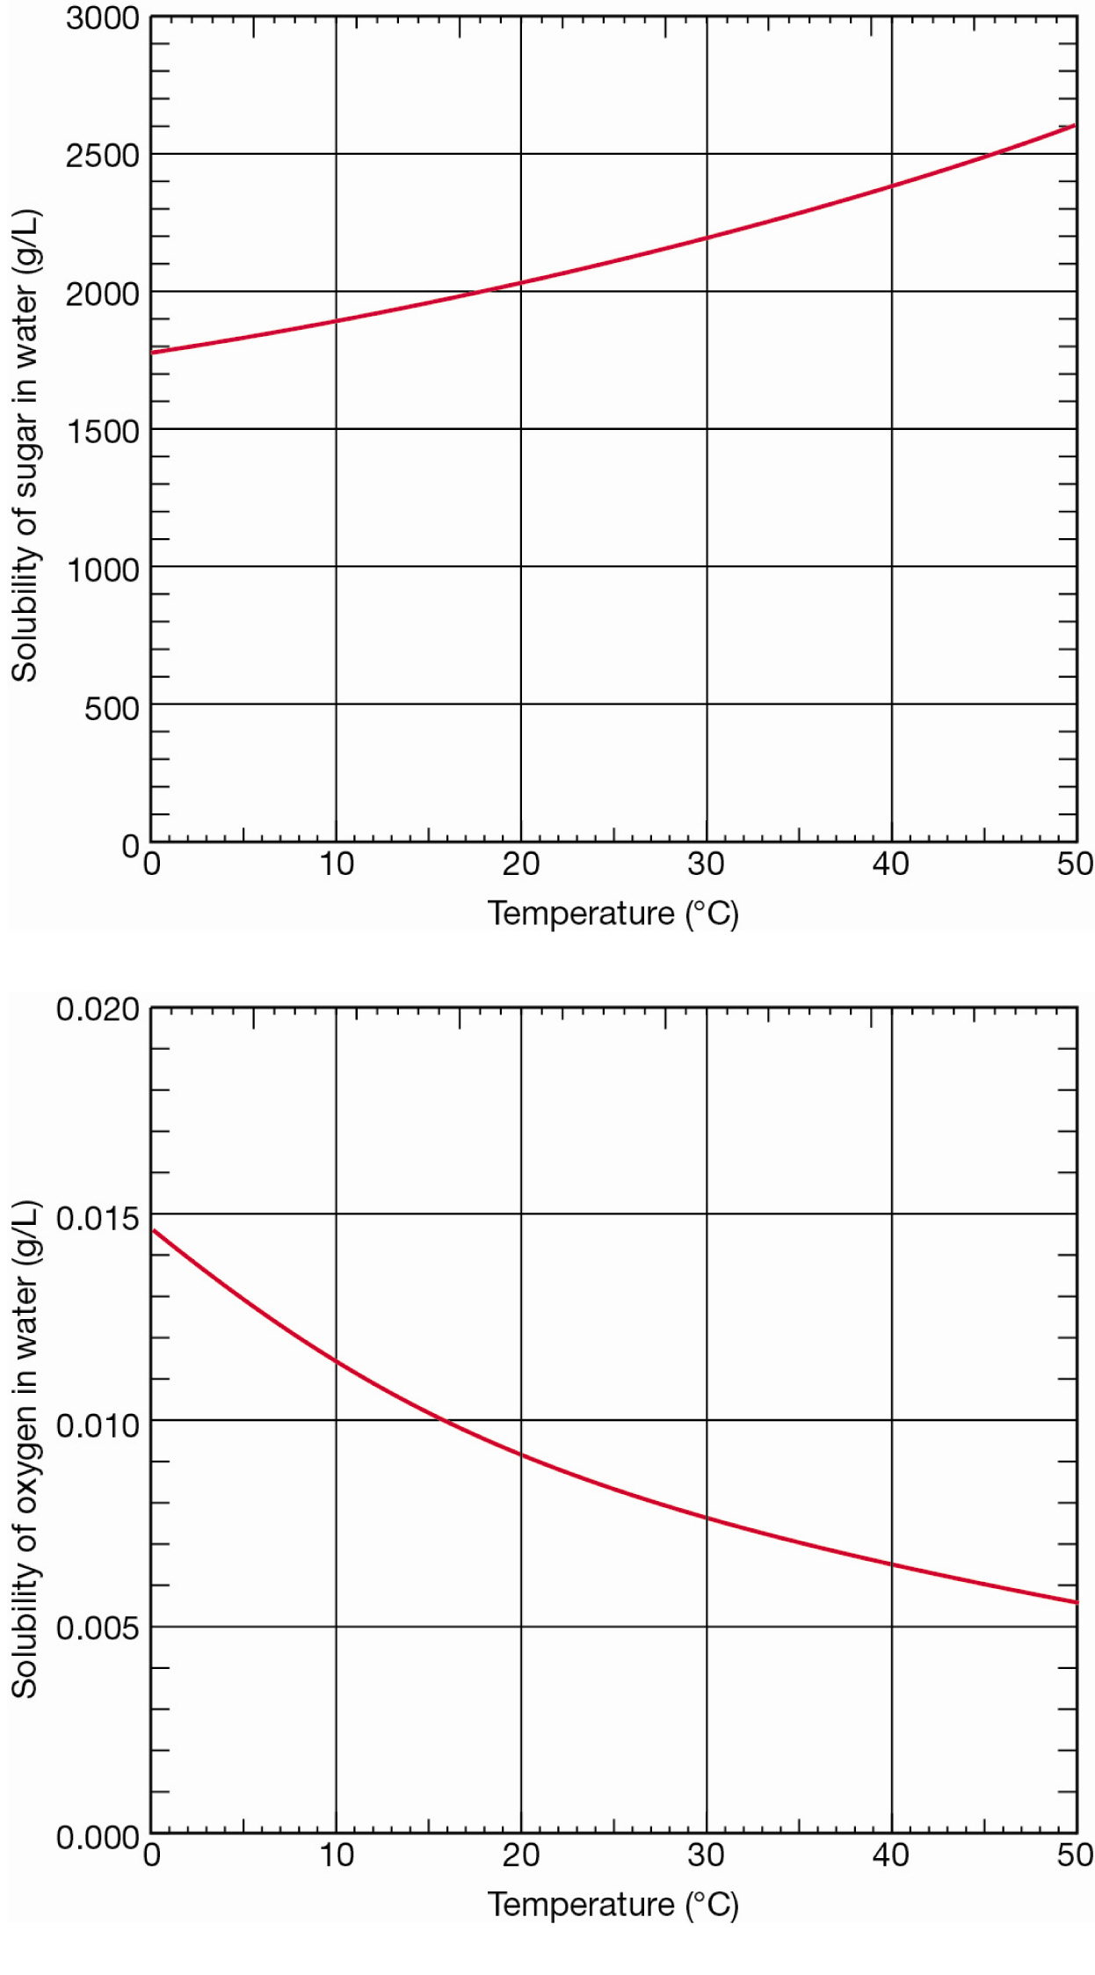

6 The data are on different scales (for example, the solubility of oxygen is much less than the solubility of sugar so if you plotted them on the same axes, you would not be able to see the solubility data for oxygen).
7 The solubility of sugar is very high and increases as the temperature of the water increases. The solubility of oxygen is around 100,000 times lower and decreases as the temperature of the water increases.
8 To get the most concentrated solution of sugar in water, increase the temperature of the water as much as possible.
9 To get the most concentrated solution of oxygen in water, decrease the temperature of the water as much as possible.

